8th International Symposium on Aggregates (2016) Kutahya, Turkey

*Int. J. Econ. Environ. Geol. Vol. 8(1) 41-45, 2017*

*Journal home page: www.econ-environ-geol.org*

***Open Access***

***ISSN: 2223-957X***

**Environmental Impact of Sand Mining in Malir River Bed Karachi, Pakistan**

**V. Husain¹*, G. Hamid1, M. Bilal¹, R. Yassen¹ and S. Anjum²**

¹Department of Geology, University of Karachi, Karachi, Pakistan

²Department of Geology, Federal Urdu University, Karachi, Pakistan

*Email: [prof.viqarhusain@yahoo.com](mailto:prof.viqarhusain@yahoo.com)

**Abstract:** Extraction or mining of sand and gravel from river beds/flood plains plays an important role as aggregate in construction industries but has placed immense pressure on the environment, where sand and gravel resources occur. Present study was carried out to determine the environmental effects of sand and gravel mining in Malir River bed in Karachi. Field work was carried out in the study area to determine the physical environmental effects of mining. Results show that destruction of landscape, reduction of farm, grazing land and lowering of water table are the environmental effects that result due to sand and gravel mining in Malir River. Due to continuous open pit mining of the sand and gravel deposits of more than 100 ft thickness, the underlying bed rock which is a part of Gaj Formation of Miocene age is exposed on the surface of river bed, which may destroy the existing aquifer system in near future. Sand mining is widespread and highly unregulated in the Malir area. It is concluded that the government develops and implements policies designed to protect the environment around Malir sand and gravel mining areas in Karachi.

# Introductıon

Aggregate is a substance made from several materials such as river sand and gravel (Schaetzl, 1990). Besides, sand and gravel being useful resources in construction industry are also useful tools in flood control and river stabilization (Chimblodza, 2012). Sand mining and gravel extraction are a worldwide activity in both developed and developing countries (Draggan, 2008). Sand being cheap and readily accessible resource is being mined both legally and illegally all over the world including Pakistan. The sand mining is being done without considering the damage, it is causing to the environment (Draggan, 2008). Further, river sand, pit sand and gravel are mined around large expanding areas (Schaetzl, 1990). The area of present study is Malir River in Karachi. It has been the major source of construction sand for over 100 years for Karachi city of about 20 million people. Though, several Karachi based soil testing companies have carried out geotechnical studies of aggregate resources of Malir River, but published data is very much lacking.

The study area lies between latitude 24° 56’ 22” and longitude 67° 18’ 45” (Fig. 1 a, b). In Malir, operations include site clearing to remove vegetation then mining and transportation to construction sites in the city leaving the mined area unreclaimed. Machinery commonly used for mining includes bulldozers, tractors, scrapers and front loaders. Excessive extraction of sand and processing for constructing concrete blocks has destroyed scenic landscape in the area.

**Materıals and Methods**

This work is aimed at assessing the environmental impact of sand and gravel mining in Malir River bed in Karachi. On the field, data were obtained using a global positioning system (GPS) which was used to record coordinates for the location of mining activities in the area. Field photographs were taken because of their importance in this study. Field observations were made in order to note the existing physical impacts of sand mining on environment and aquifer system in the study area.

**Results and Dıscussıon**

## Geology of the Area

The Malir River bed consists of surficial alluvium deposits of Holocene age. These deposits are mainly composed of sand, silt and clayey materials with thin layers of gravels. Most of the mining of sand is being done from these deposits. Malir River bed overlies Gaj Formation of Miocene age as a truncated surface. Gaj Formation consists of limestone, sandstone, shale and minor conglomerate. Limestone is yellowish brown to dark brown, cream in color, fossiliferous, hard, sandy and argillaceous (at places) marls. Sandstone is soft, fine grained, yellowish brown to gray. Shale is greenish gray, gypsiferous interbedded with sandy limestone and calcareous sandstone.

## Field Observations

Goddard (2007) indicated that sand and gravel extraction and processing have significant negative effects on the

Copyright © SEGMITE

©SEGMITE

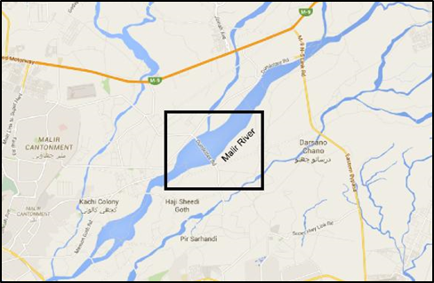

Fig.1a Location Map of the study area.

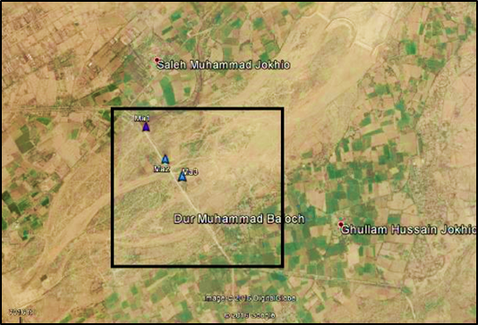

Fig. 1b Locations of sand and gravel quarries in Malir River.

landscapes. The study area of Malir has been badly affected by destruction of Coconut and mango plantations (Fig. 2). The whole topography is marked by shallow and deep cutting of river sand terraces. According to Bagchi (2010), there is contamination of sand aquifer water due to formation of ponds as mines tend to dig on areas with thick sand bed creating water ponds.

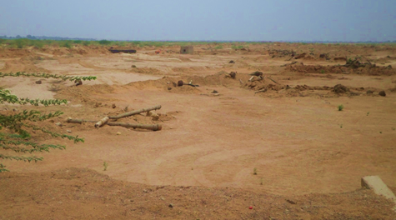

Fig. 2 Destruction of Coconut trees.

### Physical Environmental Impact

Results from field observation showed that one of the physical effects of sand and gravel mining in Malir River bed is the reduction of farm lands and grazing lands (Fig. 3). This is because when sand and gravel is to be extracted, vegetation is destroyed and this vegetation serves as food for their cattle. This then denies both animals and inhabitants in the area their means of livelihood.

Continuous mining causes complete removal of vegetation and destruction of topsoil and subsoil resulting in a reduction in faunal population (Fig. 4). Kuttipuran (2006) supported this impact by noting that loss of vegetation and ecosystems is common around and next to Indian rivers, an eyesore which gives an offensive look to the natural beauty of the environment. Still in India, Pereira (2012) recognised that there is destruction of mangrove forests due to illegal construction of storage docks, roads, infrastructure for easy mining, storage and transportation of sand from the rivers.

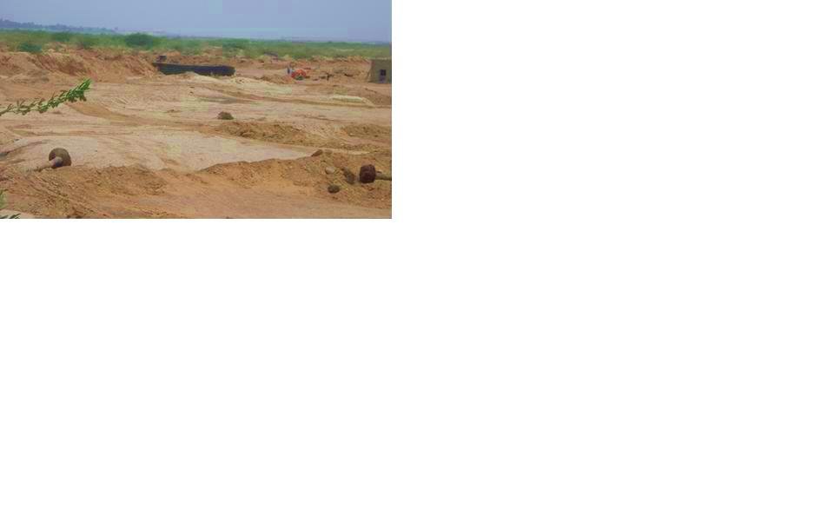

Fig. 3 Malir River bed mining showing the reduction of farm lands and grazing lands.

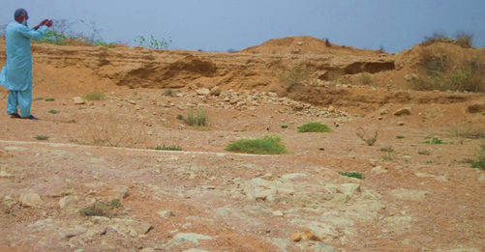

Fig. 4 Showing complete removal of vegetation and destruction of topsoil and subsoil.

Saviour (2012) discussed the destruction of existing vegetation and soil profile significantly in topsoil affecting flora and fauna in Indian regions as, mining continues. Landscape destruction is one of the significant effects of mining in the area. The original landscape has been destroyed and altered as a result of excavated pits and trenches, leaving behind unpleasant sights, which render the land unsuitable for any productive purpose. During the raining season these pits collect and store stagnant water and as such, serve as breeding ground for pests such as mosquitoes, which in turn can affect the health of the people living in and around the area.

There is collapse of river banks in the area due to sand and gravel mining (Fig. 5). The extraction of sand and gravel around and within the Malir River makes the banks of the river weaker leading to their gradual collapse. Bagchi (2010) discussed environmental land and surface degradation as a serious impact of in stream mining on Indian rivers. There is damage to river banks and general ecosystems due to access ramps to river bed. Continuous removal of sand from river bed increases velocity of flowing water which erodes beds and banks. Kondolf (2007) noted that as the velocity increases, the river bed can propagate both upstream and downstream for many kilometers. This can lower alluvial water tables.

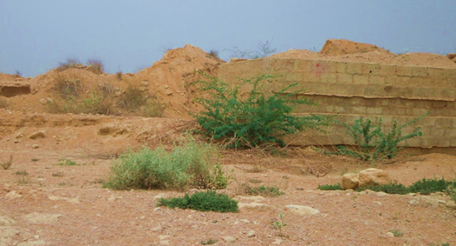

Fig. 5 Showing collapsing of Malir River banks.

Air pollution is also one of the environmental impacts observed in the area. Air pollution caused by dust particles can be a health hazard causing respiratory disorders, such as asthma and irritation of lungs (Saviour, 2012). The sand is also extracted from rock blasting, which generats noise pollution in the study area.

Stebbins (2006) noted that as mining occurs, there is loss of protection provided by sand and gravel, as it filters out pollutants. Gravel pits are sometimes, used as dumping sites with tipper trucks carrying waste to dump, as they come to collect sand and gravel. Tailing and waste dumps from mining processes pollute ground water resources near mining areas and contaminate soils.

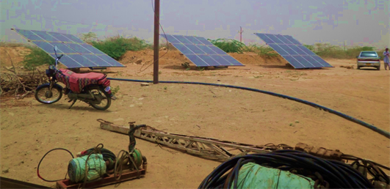

Fig. 6 Solar panels producing electricity for the area.

### Lowering of Watertable

Malir River bed has become victim of indiscrimate sand mining, which has lowered the water table to 150 ft. It is feared that continuous sand excavation in the area will further lower the water table and drying up of wells in the area in near future. It has also been observed that those engaged in illegal mining of sand in the area have also started digging wells and taking out water with solar electric motors to supply water through tankers to water scarce city of Karachi at exorbitant rates (Fig. 6).

Pereira (2012) revealed that sand mining is a threat to water security resulting from loss of groundwater storage due to lowering of alluvial water table. A lowered water table due to mining leaves drinking water wells dry and people starving. Sand acts as a reservoir to charge groundwater wells, so when removed, wells have to be dug deeper, which increases water costs (Pereira, 2012). Stebbins (2006) researched that co-existence of gravel sand mines and water supply harms the groundwater quality. In Malir River bed due to continuous extraction of sand and gravel, groundwater level is being lowered and instead of dug well, percussion well is recommended to drill in bed rock (Gaj Formation) in the study area (Fig. 7). The Gaj Formation is mainly argillacous in nature consisting of thick beds of shale intercalated with thinly to thickly bedded limestone. Therefore, the water extracted from perched aquifer confined in beds of shale is saline in nature and not suitable for drinking, construction as well as agricultural purpose.

### Economic Impacts

The study area is currently experiencing sand and gravel mining in considerable quantities and this has resulted in various economic activities including the use of sand in road and concrete blocks for construction of road and structures in Karachi (Fig. 8). Sand and gravel had been a useful natural resource for thousands of years worldwide and are fundamental to human existence. Schaetzl (1990) discussed sand and gravel as crucial resources to economic development activities, when making aggregate in United States of America.

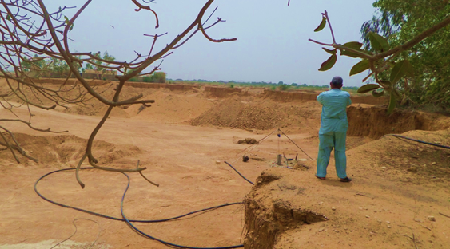

Fig. 7 Showing drilling of percussion well in bed rock.

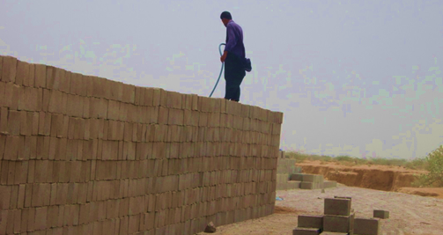

Fig. 8 A man watering the concrete blocks in the area.

Kondolf (2007) supported the use of active channel deposits (gravel and sand) as desirable for construction aggregates because they are durable, well sorted and frequently located near market and transportation routes. Kuttipuran (2006) supported Goddard (2007) when he discussed the importance of sand and gravel in Indian economy as cheap and most accessible used in construction industry to build strong structures and road bases. Bagchi (2010) realised that sand and gravel are useful in landscaping projects, which beautify gardens in India.

Sand and gravel are important in construction and manufacturing industries, when used in building, making glass, electronic chips and ceramics. Sand mining underpins the development engine, so without sand the construction industry will come to a halt (Pereira, 2012). There is creation of employment for families at mining sites in Indian regions (Saviour, 2012). Alluvial aquifer of Malir is also a very important source of drinking as well as irrigating water. In the study area, a number of dug wells of more than 150 ft depth are providing water to the adjoining populated area (Fig. 9).

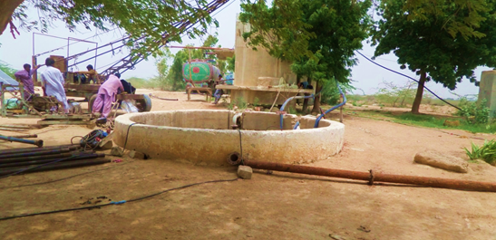Fig. 9 A dug well at the mining site.

# Sand Budget

A sand budget for a particular extraction area for example a stream or open area should be done to first determine the amount of sand that can be removed without causing degradation and erosion. Before doing a sand budget, consider mining methods to be used, particle size, characteristics of the sand, riparian vegetation and magnitude as well as frequency of hydrologic events after disturbance. Determining the sand budget for a particular stream requires site-specific topographic, hydrologic, and hydraulic information. This information is used to determine the amount of sand that can be removed from the area without causing undue erosion or degradation, either at the site or at a nearby location, upstream or downstream.

But sand budget techniques have not been applied in the Malir or other sand quarries in Pakistan. In Malir River bed, the sand mining is continuing unabated, which has created serious environmental concerns by exhausting sand reserves and destroying the fresh water alluvial aquifers.

# Mıtıgatıon Measures

The United Nations Conference on Environment and Development Report (2002) advocates sustainable use of natural resources. Goddard (2007) highlighted that man benefits from sand and gravel, as cheap and readily accessible resources for development, so there should be conservation and rehabilitation of these resources for future use. Aromolaran (2012) recommended the planting of trees and shrubs that could help to regenerate degraded land and prevent erosion.

It should be made mandatory for miners in the study area by the government agencies to fill pits after mining, then plant trees and grass to minimize erosion. People in rural areas should be educated on alternative resources to sand such as crushed stone that are less dredging to agricultural land. Pereira (2012) also suggested use of crushed stone as alternative to conserve sand. Mwangi (2007) gave mitigation measures to sand mining and gravel extraction as refilling and growing appropriate vegetation on eroded areas by licensed miners as a prerequisite.

# Conclusıon

In Malir area, to conserve sand and control environmental degradation, there should be restriction on illegal sand mining and groundwater withdrawl. The department of mines with the help of police should impose heavy fines and jail terms to check illegal sand mining. Otherwise, it is feared that over extraction of sand will deteriorate the water quality by destroying alluvial aquifer system in the area.

# References

Aromolaran, A. K. (2012). Effects of sand mining activities on land in agrarian communities of ogun state. *Continental Journal of Agricultural Science,* **6**,1.

Bagchi, P. (2010). Unregulated sand mining threatens Indian rivers. *The Journal India Together*, **21**, 7-9.

Chimbodza, P. (2012). Mineral sands mining in the Ruckomechi and Chewore rivers. http://www.victoriafalls-guide.net

Draggan, S. (2008). Encyclopedia of earth, sand and gravel. Washington DC, USA.

Goddard, J. (2007). Land degradation and rehabilita tion, Sydney, University of South Wales Press.

Kondolf, M. G. (2007). Geomorphic and environmental effects of ın stream gravel mining. *Landscape and Urban Planning*, **28**, 2-3.

Kuttipuran, M. (2006). Rıvers: Physical modifications, Singapore: Donnelley.

Mwangi, S. (2007). Management of river systems in East Africa, Nairobi: Macmillan.

Pereira, K. (2012). Illegal sand mining: The unexamined threat to water security in India. http://www.ismenvis.nic.in.

Saviour, N. M. (2012). Environmental impacts of soil and sand mining: a review. *International Journal of Science, Environment and Technology*,**1**, 125-134.

Schaetzl, R. (1990). Sand and gravel mining for aggregate: https://www.msu.edu/-soils.

Stebbins, M. (2006). Can gravel mining and water supply wells coexist, Maine: University of Maine.

United Nations Conference on Environment and Development Report, (2002). http://www.johanne sburgsummit.org